PHYS2941 problem set 4

By Samuel Allpass s4803050

Problem 7.3)

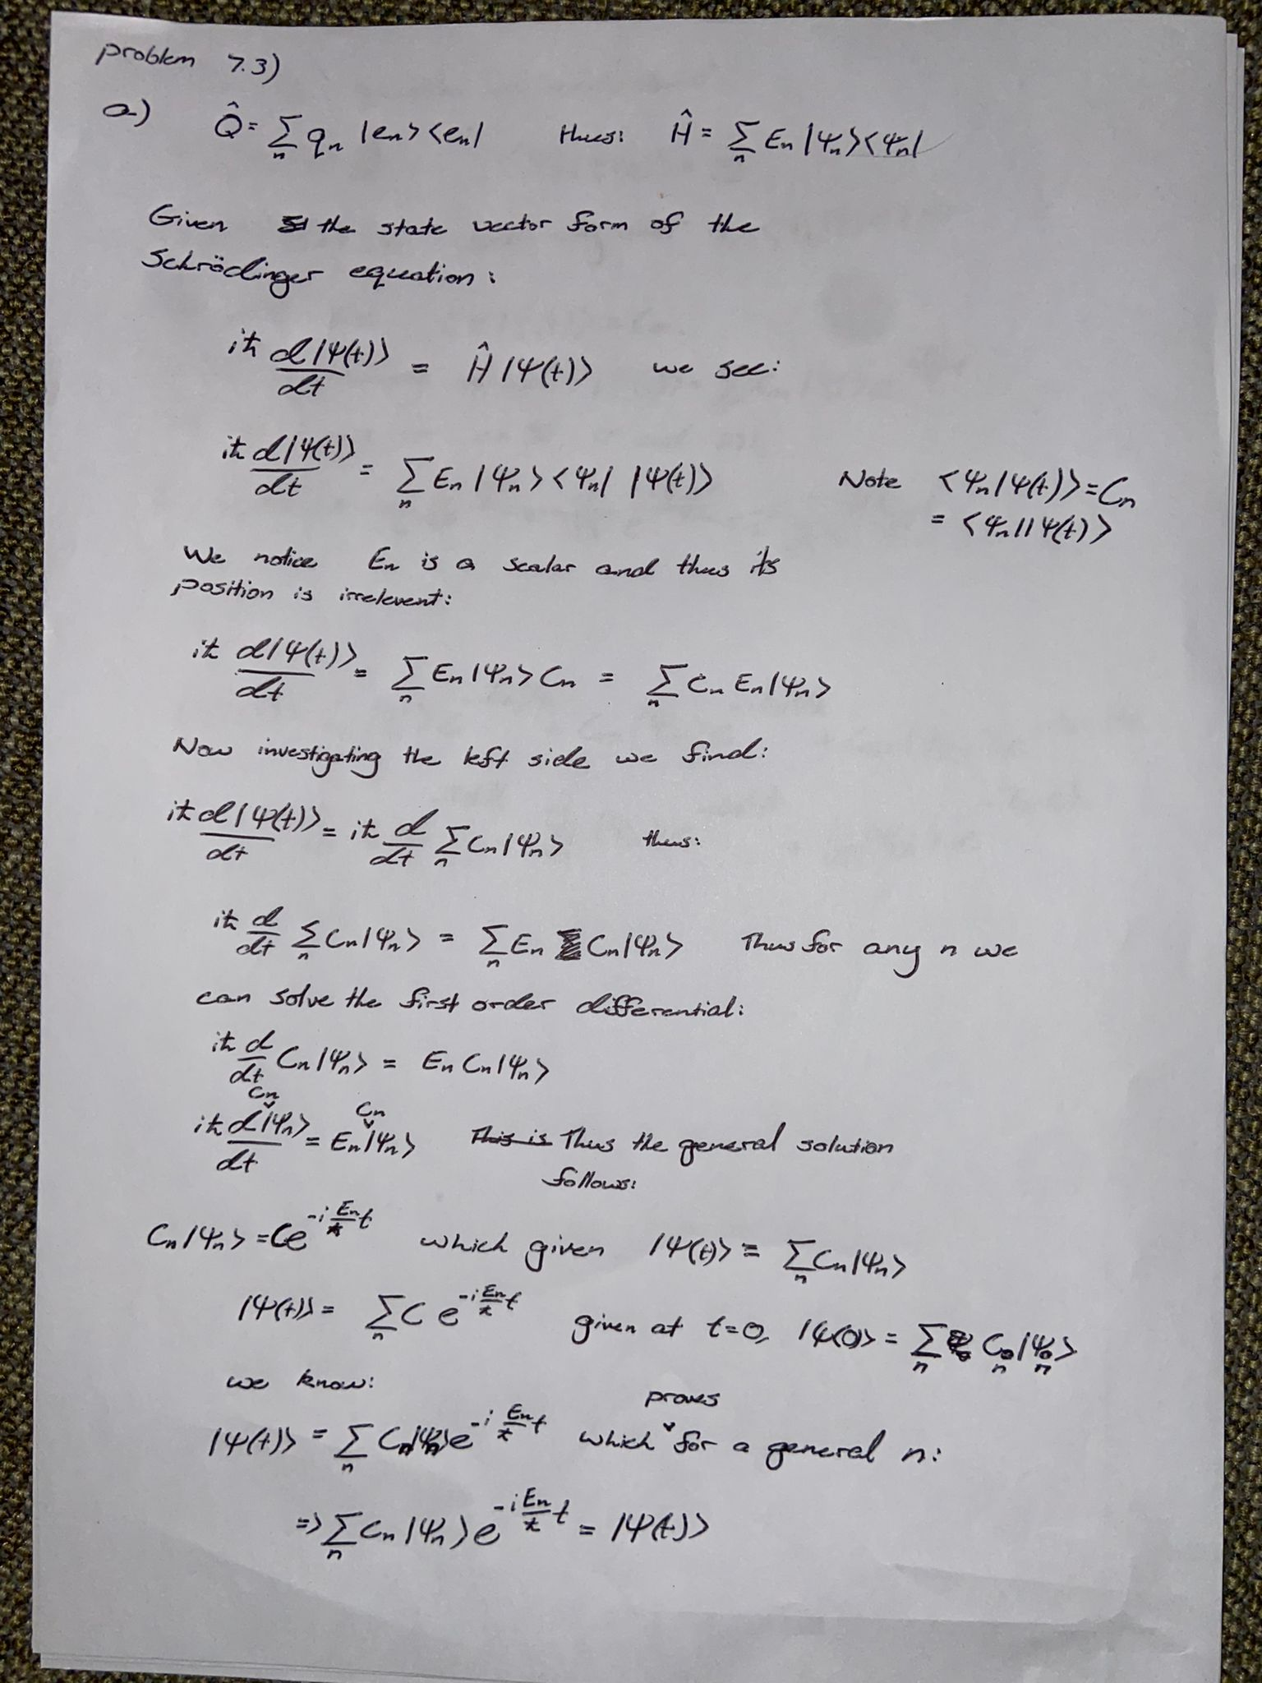

y’ + f(x) y = 0 has the general solution y =

Problem 7.4)

Note that Am,n is a scalar and can therefore be moved around. As such, we have shown that any arbitrary operator A-hat can be written as

Problem 8.4)

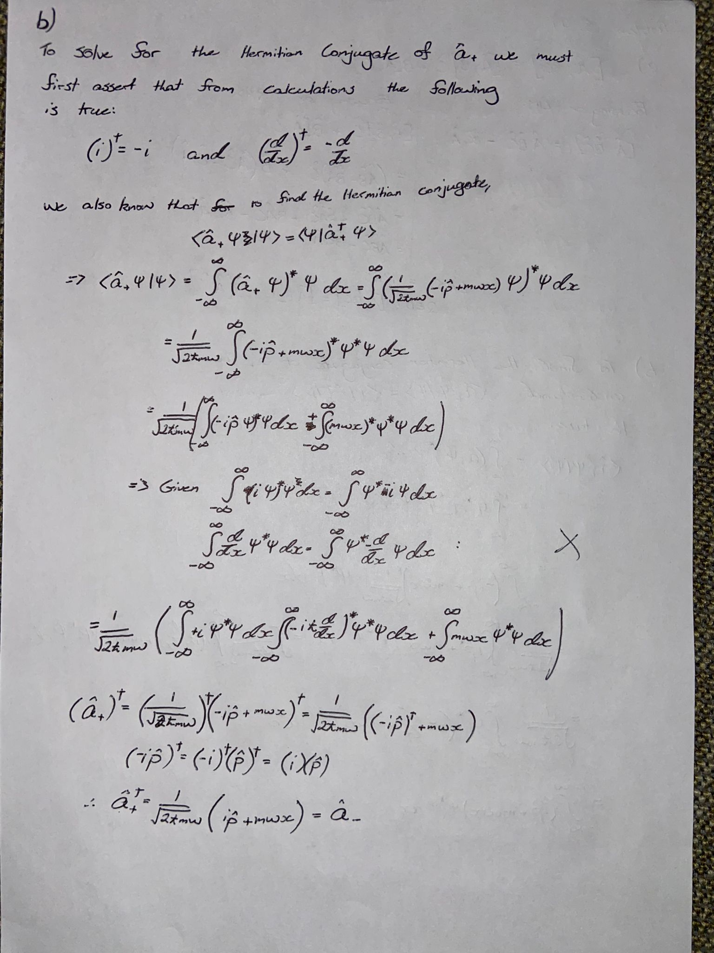

Additionally for the next two questions, let me prove a few extremely helpful identities:



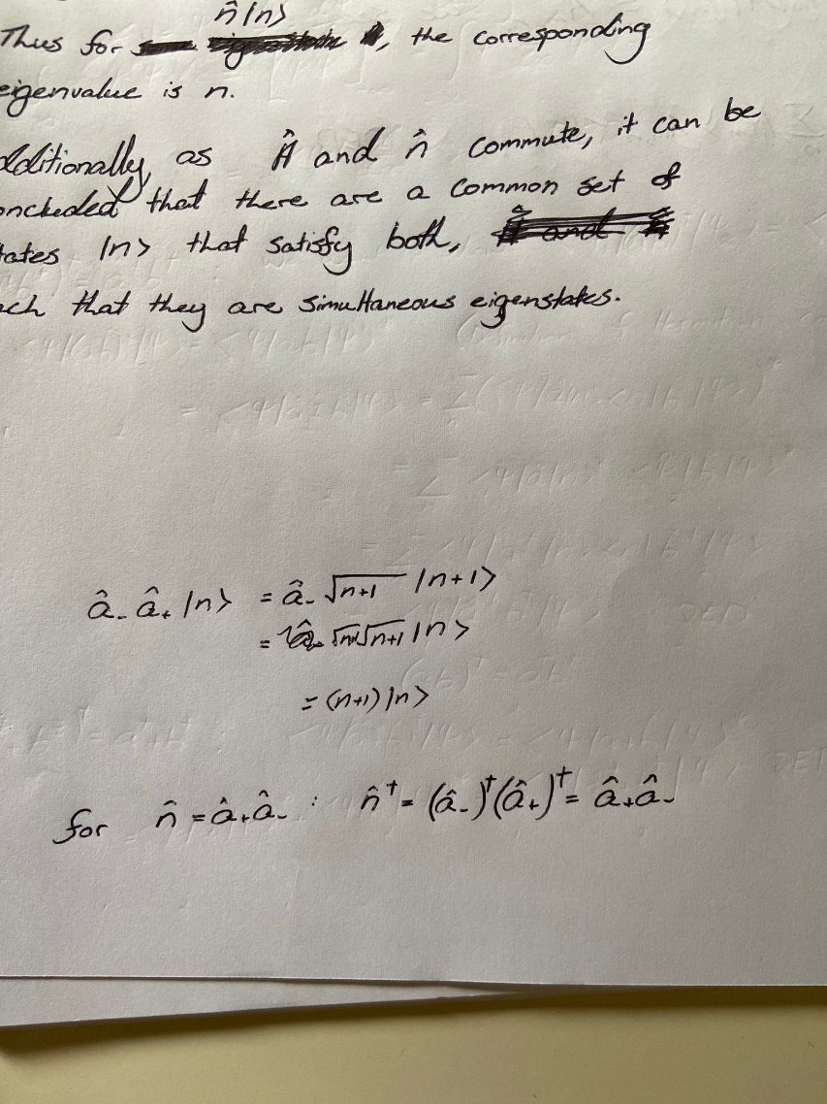

Thus, we have shown explicitly that both the sum and product of ladder operators are Hermitian.

Problem 8.5)



